JPQL : Java Persistence Query Language

SQL

Select \* from product; product is table name and not a case sensitive. this query retrieve all records from a table.

Select \* from product where pid=100;

Select \* from product where price > 50000

Select pid from product;

Select pname from product

Select pname,price from product

JPQL or HQL

select p from Product p; Product is entity class name or java bean class name. case sensitive an p is object. using p we are retrieving all variable values.

select p from Product p where p.pid=100; here p is object and pid is variable name.

retrieving partial object

select p.pid from Product p;

select p.pname from Product p;

select p.pname,p.price from Product p

spring framework with ORM : Hibernate or JPA.

Spring framework using annotation / xml we can use

1. Jdbc
2. Hibernate
3. Jpa

Spring boot with Rest API with JPA

<https://start.spring.io/>

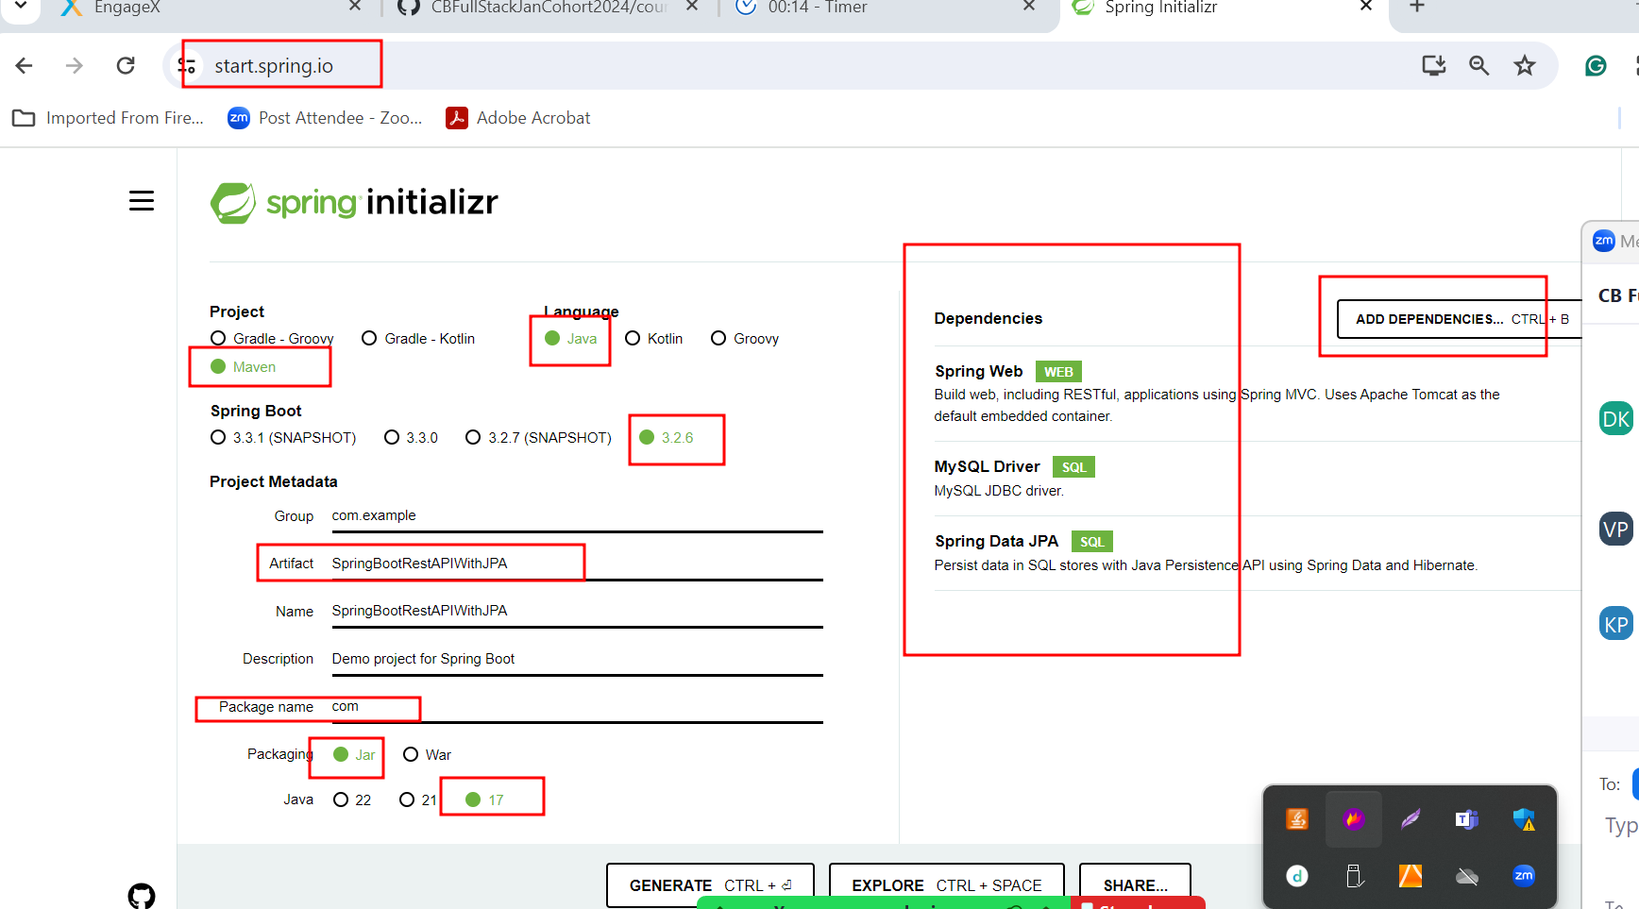

In spring boot

application.properties or application.yml

this file contains all configuration details depending upon project requirement.

Like database information

If we want to write Database Logic using JDBC or Hibernate or JPA we need to use DAO class (Data Access Object) which contains pure business logic.